Case Study: Cyberbullying Among College Students

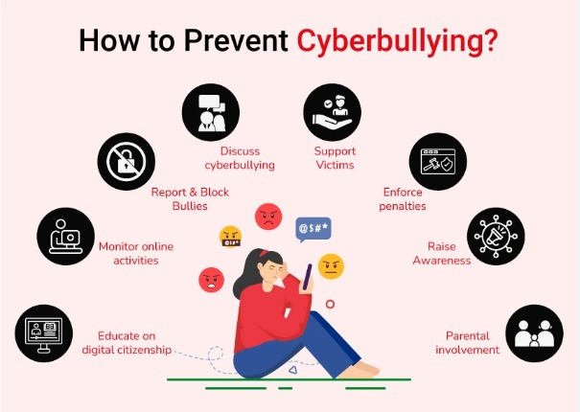

Cyberbullying is a form of online harassment where individuals are targeted through digital platforms such as social media, messaging apps, or online forums. In a typical college setting, this may begin with negative or sarcastic comments on a student’s posts. Over time, the behavior can escalate into repeated harassment, including abusive messages, public shaming, or the circulation of false or manipulated content.

The process often follows a pattern. First, the victim is identified based on visibility or vulnerability. Next, the perpetrator initiates harmful communication, often under anonymity or fake accounts. This is followed by amplification, where others join in, share the content, or encourage the behavior. In some cases, impersonation or fake profiles are created to further damage the victim’s reputation.

Cyberbullying commonly targets students who are active online, perceived as different, or less likely to respond. The consequences can be serious, including emotional distress, anxiety, reduced academic performance, and social withdrawal. In severe cases, it may impact long-term mental well-being.

Effective prevention includes strict privacy controls, awareness of digital conduct, reporting abusive behavior, and institutional policies to address online harassment.

